**Reasoning**

Probability –

nC2 = n(n-1)/2

nC1 = n

nCn = n!

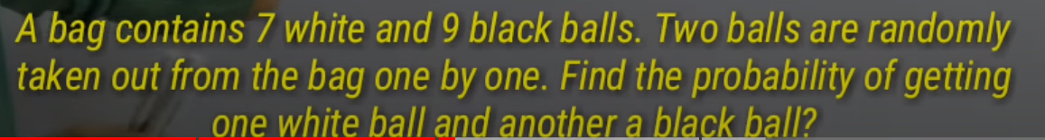

Whenever “and” is given which means u need to find out the probability alag alag.

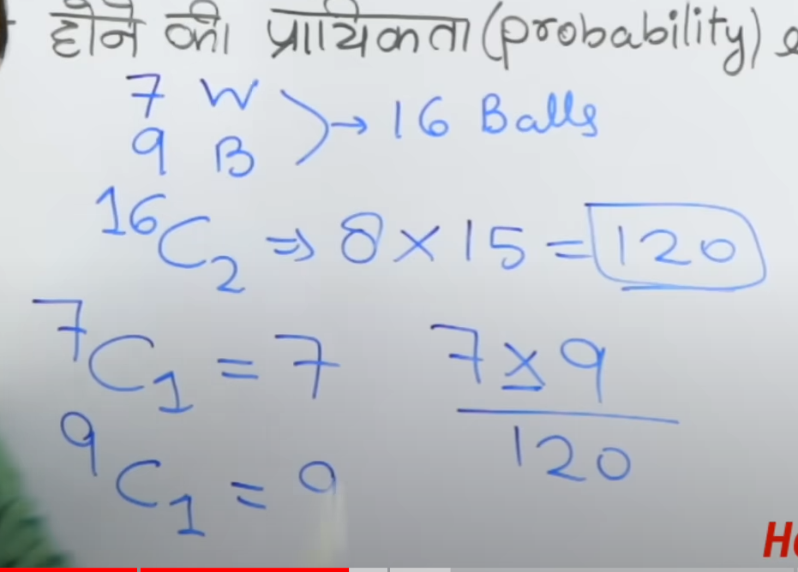

For coin the probability is 2^n, n = number of times coin is thrown.

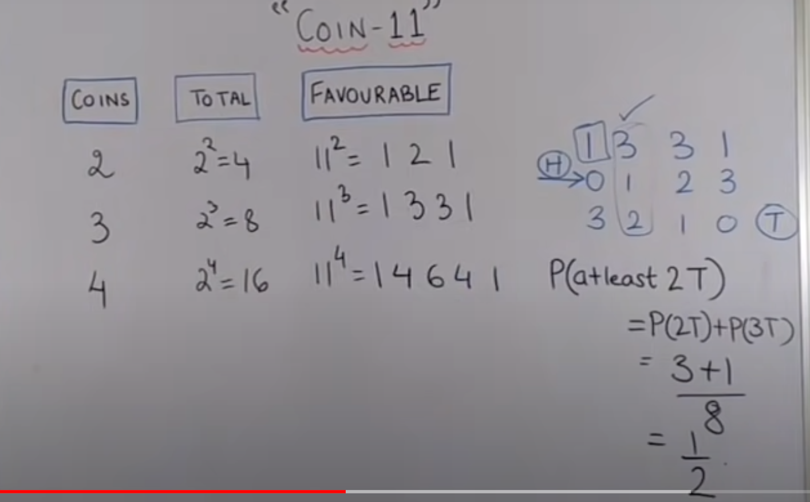 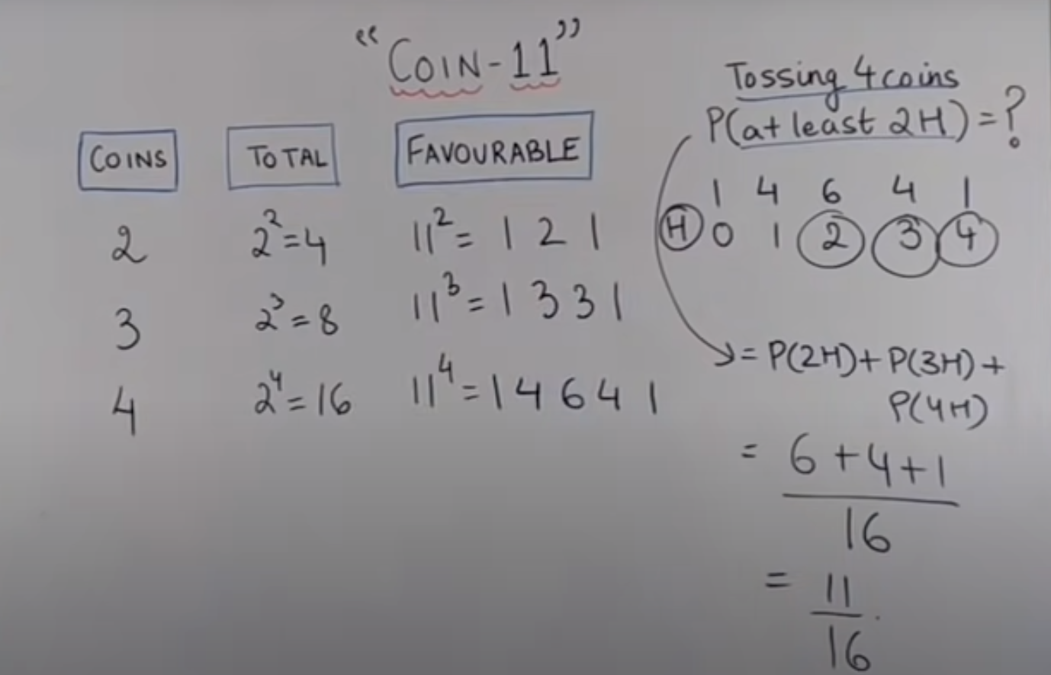

52 cards = 26 black and 26 red, 13 shape cards each. 9 number cards (36 in total) and 4 honour cards and 3 face card..

**Time and Work**

Time is inversely proportional to work.

Efficiency is also inversely proportional to time.

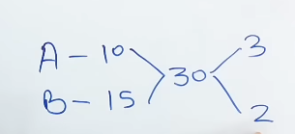 Work done in 1 day(Total work done in 1 day =3+2=5, Number of days required to domplete the work =30/5=6)

Completes work in these days.

Total Work done

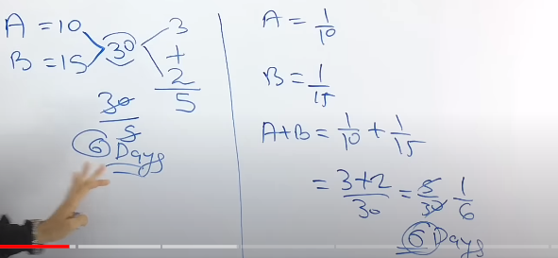

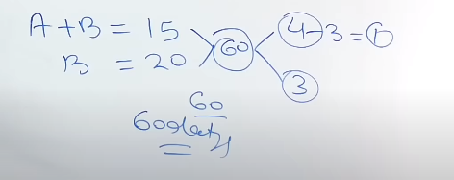

Q. If A is making twice the chair as B, they together complete any task in 12 days then, then A alone does the same work in how many days.

A B

2 : 1

12*3/2=18

Q. If Ram does some work in 18 days and Raheem does the same work in 15 days, Raheem alone does the work for 10 days and then leaves, RAM will take how many days to complete the rest of the work

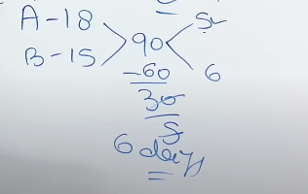

If A does ½ of thew work in 5 days and B 3/5 of the work in 9 days and C does 2/3 of the work in 8 days then how many days it will take for them to complete the work together.

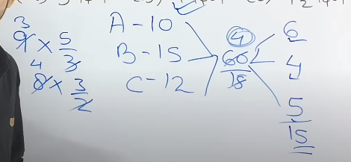 If B does 3/5th of the work in 9 days then it will complete the entire work in 5/9*3 days.

If A does a work in 12 days and B is 60% more efficient thn A, So B takes how many days to complete the work.

A does work in =12 days.

Work done by A in one day = 1/12.

B’s work in one day = 1/12*160/100

B does 2/15 work in 1 day.

Total Days taken by B =15/2=7.5.

Q. If 6 men and 8 boys does some work in 10 days and 26men and 48 boys does the same work in 2 days, then 15men and 20 boys will do the same work in how many days?

Ans – Use Chain rule = (M+B)*Days=(M2+B2)*Day2

Or else

M B

6 8

*

2.5

15 20

Then 10/2.5=4 days

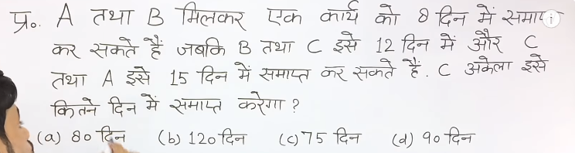

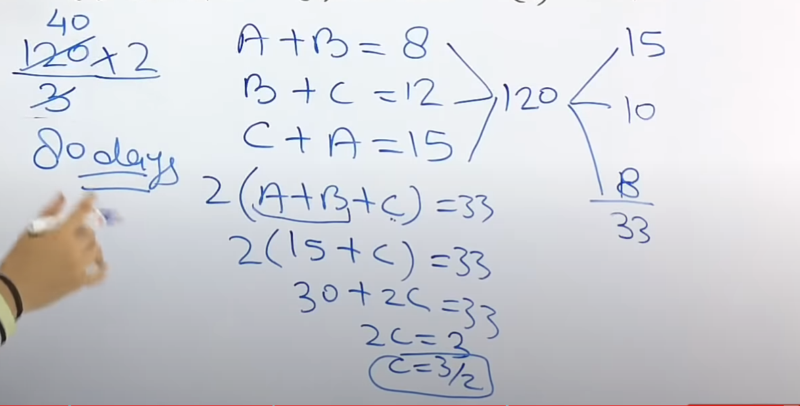

Pipe and Cistern

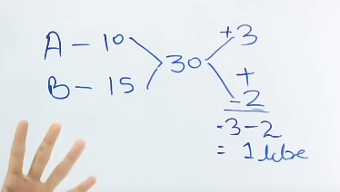

A = Paani bhr rah hai in hour

B = Paani Nikal ra hai

Net Kaam = A-B=3-2=1liter bhr rah ai ye harr hour

Time required to fill 30 liters of water is 30*1=30

Q. A=3B in terms of work efficiency. If they complete the work together in 36minutes then the slow pipe alone will do the work in how many minutes.

A : B

1 : 3

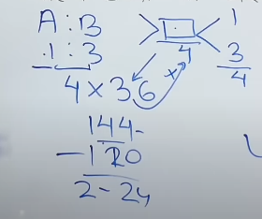

Total Efficiency =4

Work done in 1 unit time =4

Work done in 36minutes =36*4=144

144= 2hrs 24mins.

Ratio and Proportion –

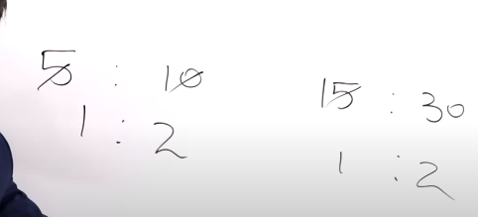

Comparing Two Same Values of same unit is called Ratio.

Comparing Ratios is called Comparison.

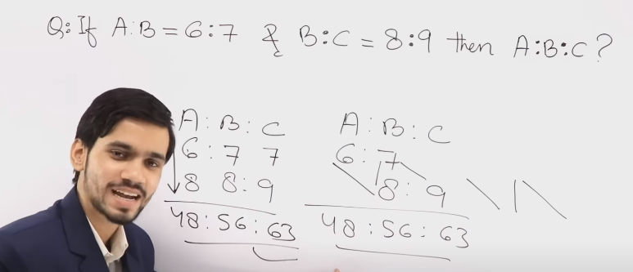

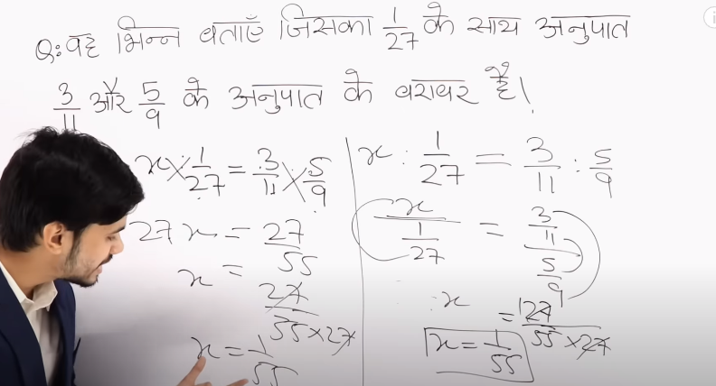

Q. Sum of 2 numbers =40 and Difference of 2 numbers =4. Find the Numbers?

Add it = 40+4 = 44

Subtract it = 40-4 = 36

44:36 =11:9

If 2A=3B then the ratio is 3:2

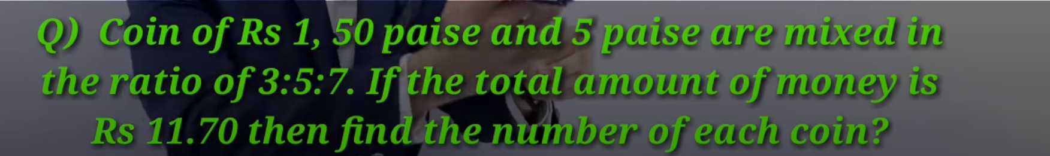

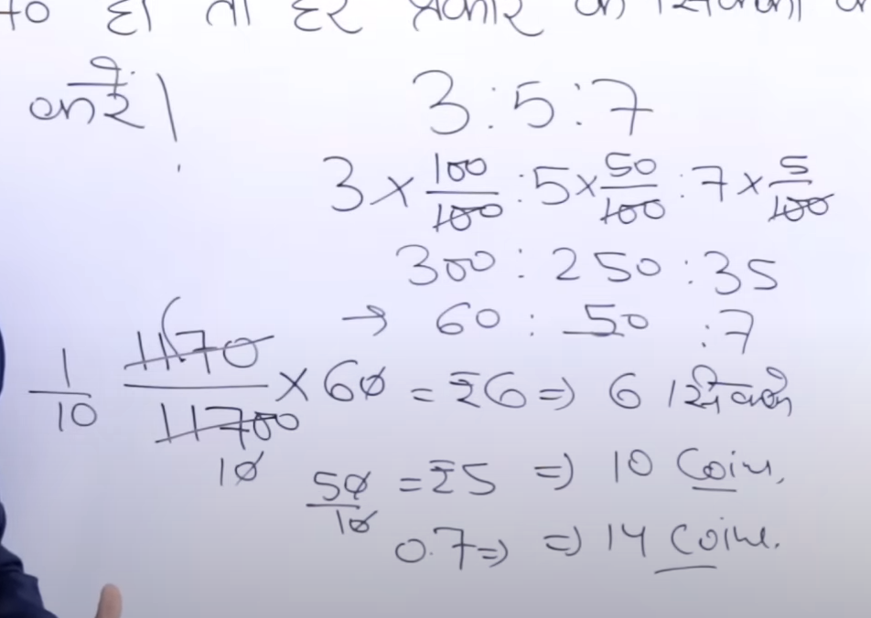



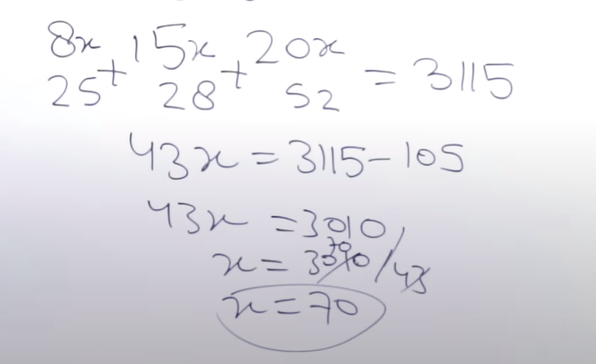 8*70=560

Allegations and Mixtures –

Milk : Water

9 : 1

Take out 2 liters

In both the mixture now the ratio will 9:1 only.

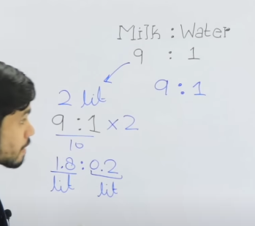

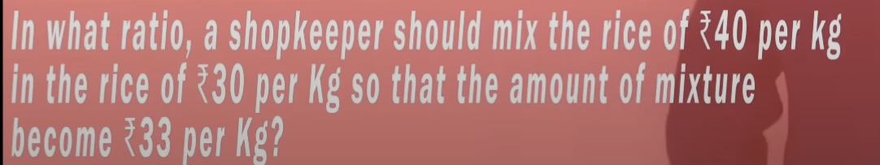

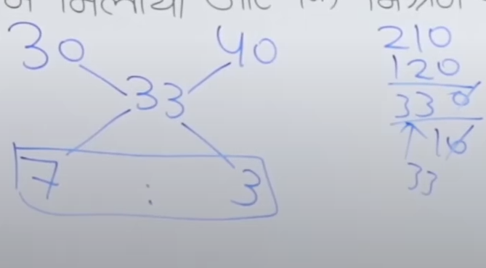



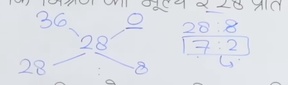 Milk =0Rs



The profit Value is added to 96 so take out Profit value from it

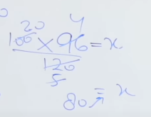 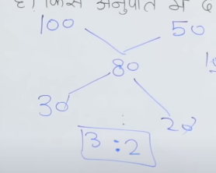

A jar contained a mixture of 2 liquids in the ratio 4:1. Ten liters of the mixture was taken out and liters of liquid B was poured in a jar and now the ratio is 2:3. The quantity of liquid B initially.

A : B

4 : 1

+10 liters of B

2 : 3

We did not add A so making it same again.

*2

4 : 6

If we look at B 5 unit changed but as we multiplied by 2 we have to didvide it now by 2 so,

5/2unit =10

1unit =4

B ka initial unit = 4L

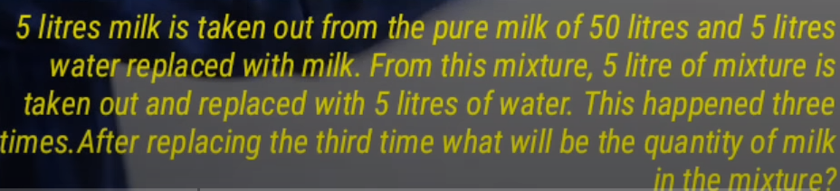

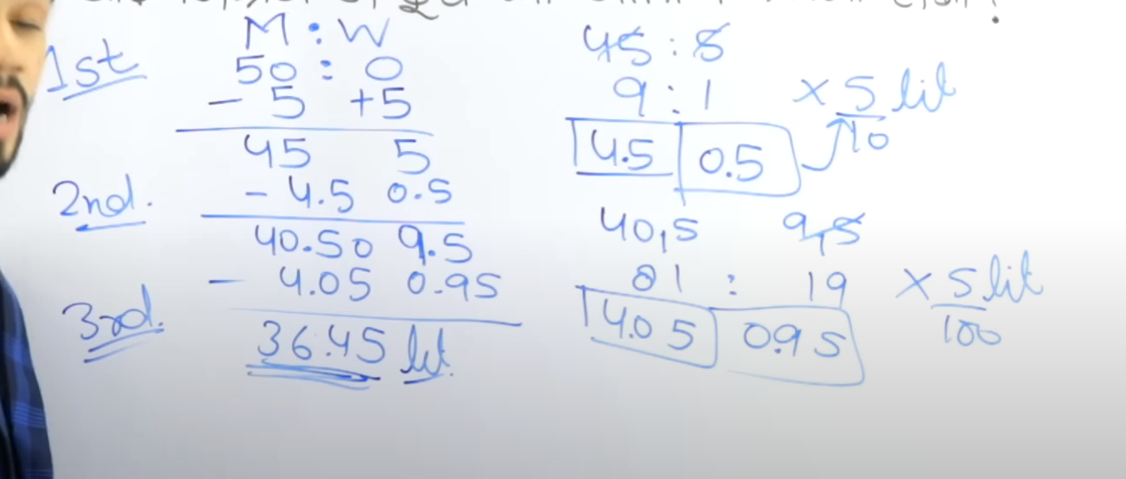

Short Trick –

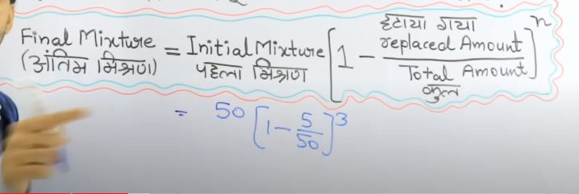

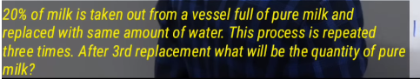

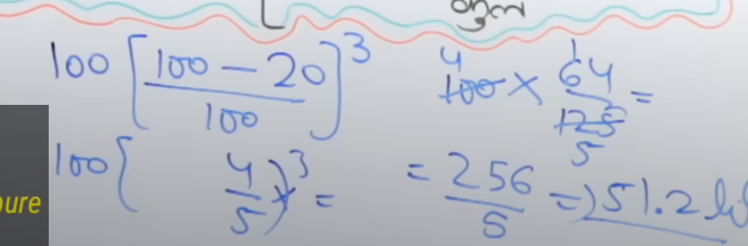

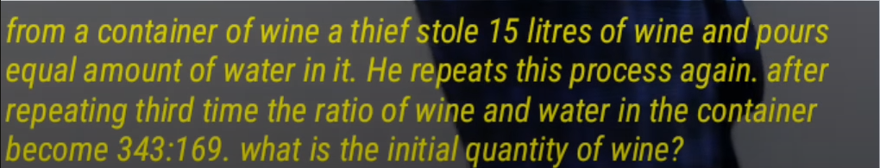

Jitna Water daala hoga utna hi wine nikala hoga so

Total mixture initially ya total wine = 343+169=512unit

343x= final quantity of wine

343x=512x(1-15/215x)^3

512x=120L

512x is initial quantity of the mixture.

